Apple iPad Air (5th gen)

Type of device: Tablet
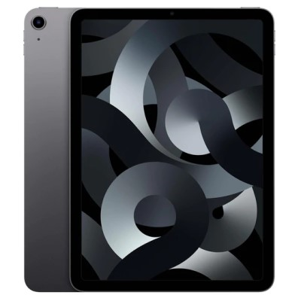

Actual Display Size : 10.9 inches
Operating System : Apple IOS
Network Capability : 3G,4G,5G
Year of Release : 2022
Average Price : $1274 as of 14 06 2022
Internet Access : Wi-Fi and Mobile Broadband

Accessibility Features:

Cognitive
- Additional Instructions
- Copy and Paste
- Flicker Free Display
- GPS
- Photo Telephone List
- Screen Timeout Disabled
- Simple Instructions
- Simple Reminders
- Simplify Display
Voice Notes

Hearing Impairment and Deaf
- Allows for sign language communication
- Bluetooth or Wi-Fi
- Closed Captioning
- Front Facing Camera
- Hearing Aid Microphone Coupling
- Hearing Aid Telecoil Coupling
- Text Messaging/SMS
- Vibrating Alerts - Adjustable
- Video Communications - Two-way
Visual Alerts - Incoming Calls

Vision
- Accessibility APIs supported
- Battery Alert - Audible
- Bluetooth or Wi-Fi
- Braille Display Support
- Brightness Adjustable
- Dictation / Speech-to-Text
- High Contrast Mode
- Personalised Shortcuts
- Power Cue
- Screen Magnifier
- Screen Reader
- Text Size Adjustable
- Text Style Adjustable
- Voice Control /Personal Assistant
Voiced Menus

Speech
- Allows for sign language communication
- Bluetooth or Wi-Fi
- Messaging Options - Email
- Messaging Options - IM
- Messaging Options - MMS
- Predictive Text
SMS Personalisation and Reuse

Physical
- Automatic Answer
- Bluetooth or Wi-Fi
- Dictation / Speech-to-Text
- Gesture Based Navigation
- Predictive Text
- Reduced hand movement option
- Speaker-phone option
- Stylus or Prosthetic Device support
- Switch control option
- Visible Focus Indicators
- Voice Control / Personal Assistant
- Voice Recognition for Accessing Features
Voice Recognition for Dialling

How and where to get it from?
You can buy this tablet from Telstra, Optus, Vodafone, JB Hi-Fi, The Good Guys, Apple, and other retailers.

More information is available on:
Apple iPad Air (5th gen) Website
Apple iPad Air (5th gen) User Guide Website

